Company ： JIANGSU LABONCE INSTRUMENT CO., LTD.
Address ：1F , 2F , NO.5 STANDARD FACTORY IN THE PIONEER PARK OF SMES, ECONOMIC DEVELOPMENT ZONE IN ZHENXING NORTH ROAD AND THE WEST OF WULING SOUTH ROAD , TAIZHOU CITY, JIANGSU PROVINCE, CHINA
Contact Person:Guston
Tel：+86-010-56545023 +86-13811790181
Fax ：010-56545070
E-mail ：export@labonce.com
Website：www.labonce.com

- Destination: | Within China
- Payment: | Negotiate
- Delivery Date: | 30-35 days
- Packing: | Wooden box package
- Freight age: | Within China
- Guarantee: | 1 year
- After-sale Service: | 24 hours online service
⑻ Others:
Our company is specialized in the research &development and production of stability chambers. We adopted advanced Germany technology, reasonable structural design, and high-quality imported components, to supply stable, safe and reliable chambers.
1、Adopt the latest air duct system design, the temperature uniformity of different position inside the chamber is good；
2、Fully enclosed industrial compressor imported from Europe, high efficiency and low noise, ensure the long-term continuous operation of equipment；
3、European original imported temperature integrated sensor, with high sensitivity, low annual drift, direct detection without maintenance;
4、Imported temperature controller, quick induction, small system error；
5、Equipped with an alarm system that meets the requirements of GMP, a data collection system that meets the requirements of GMP, and a standard pin printer and U-Disk storage;
6、The liner material is full mirror stainless steel 304, easy to clean.
Description | Model | Unit | Quantity | FOB price | Notes
Constant Temperature Test Chamber | Labonce-50CT | set | 1
Constant Temperature Test Chamber | Labonce-400CT | set | 1
Constant Temperature Test Chamber | Labonce-500CT | set | 1
Constant Temperature Test Chamber | Labonce-800CT | set | 1
Total:

Technical Parameter：
Name | Constant Temperature Test Chamber
Model | Labonce-50CT | Labonce-400CT | Labonce-500CT | Labonce-800CT
Temperature Range | 0℃～85℃
Temperature Fluctuation | ±0.5℃
Temperature Deviation | ±1.0℃
Uniformity | Balanced temperature regulation method
Refrigeration system | Imported totally enclosed compressor
Controller | Touch screen temperature controller
Data backup | Flash memory with U-Disk
Deviation alarm | Field temperature upper and lower limit deviation alarm
Double protection | Independent over temperature protection system alarm
Ambient temp | ＋5～35℃
Interior material | Full mirror stainless steel 304 material
External material | The out shell is plastic sprayed steel plate
Double door structure | Inner door tempered glass door
Power source | AC 220V±10% 50Hz
Safety device | Compressor overheating, over pressure, overload protection and fan overheating protection.
MAX power （kW） | 1.0 | 2.0 | 2.2 | 2.5
Capacity (L) | 50 | 400 | 500 | 800
Interior dimensions  W×D×H (mm) | 400×310×350 | 600×700×950 | 680×680×1070 | 1200×490×1360
External dimensions  W×D×H(mm) | 590×520×740 | 780×1060×1750 | 840×1050×1850 | 1390×890×1960
Trays (standard) | 2 | 3 | 4 | 4
GW | 95KG | 185KG | 300KG | 395KG
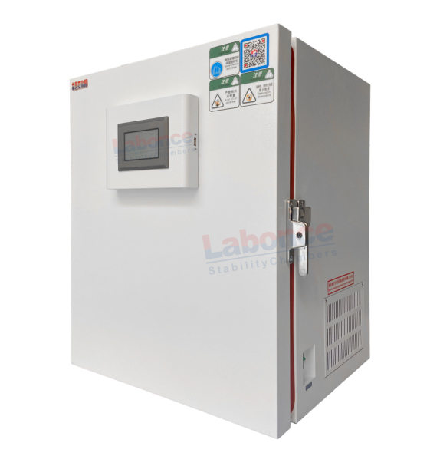

50L

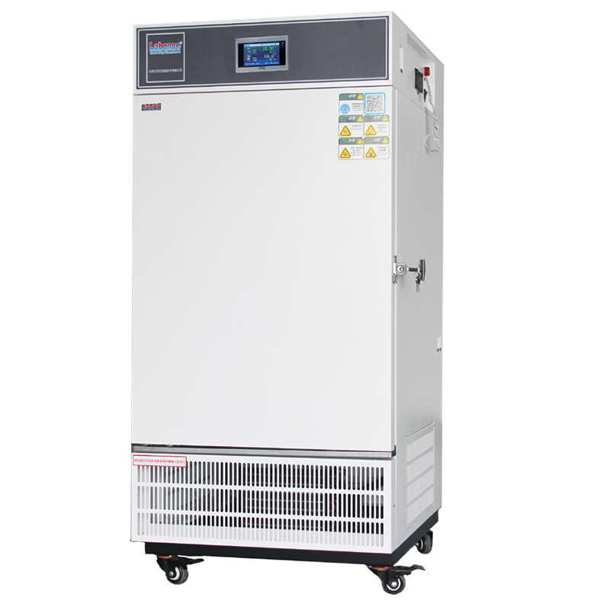

150~500L

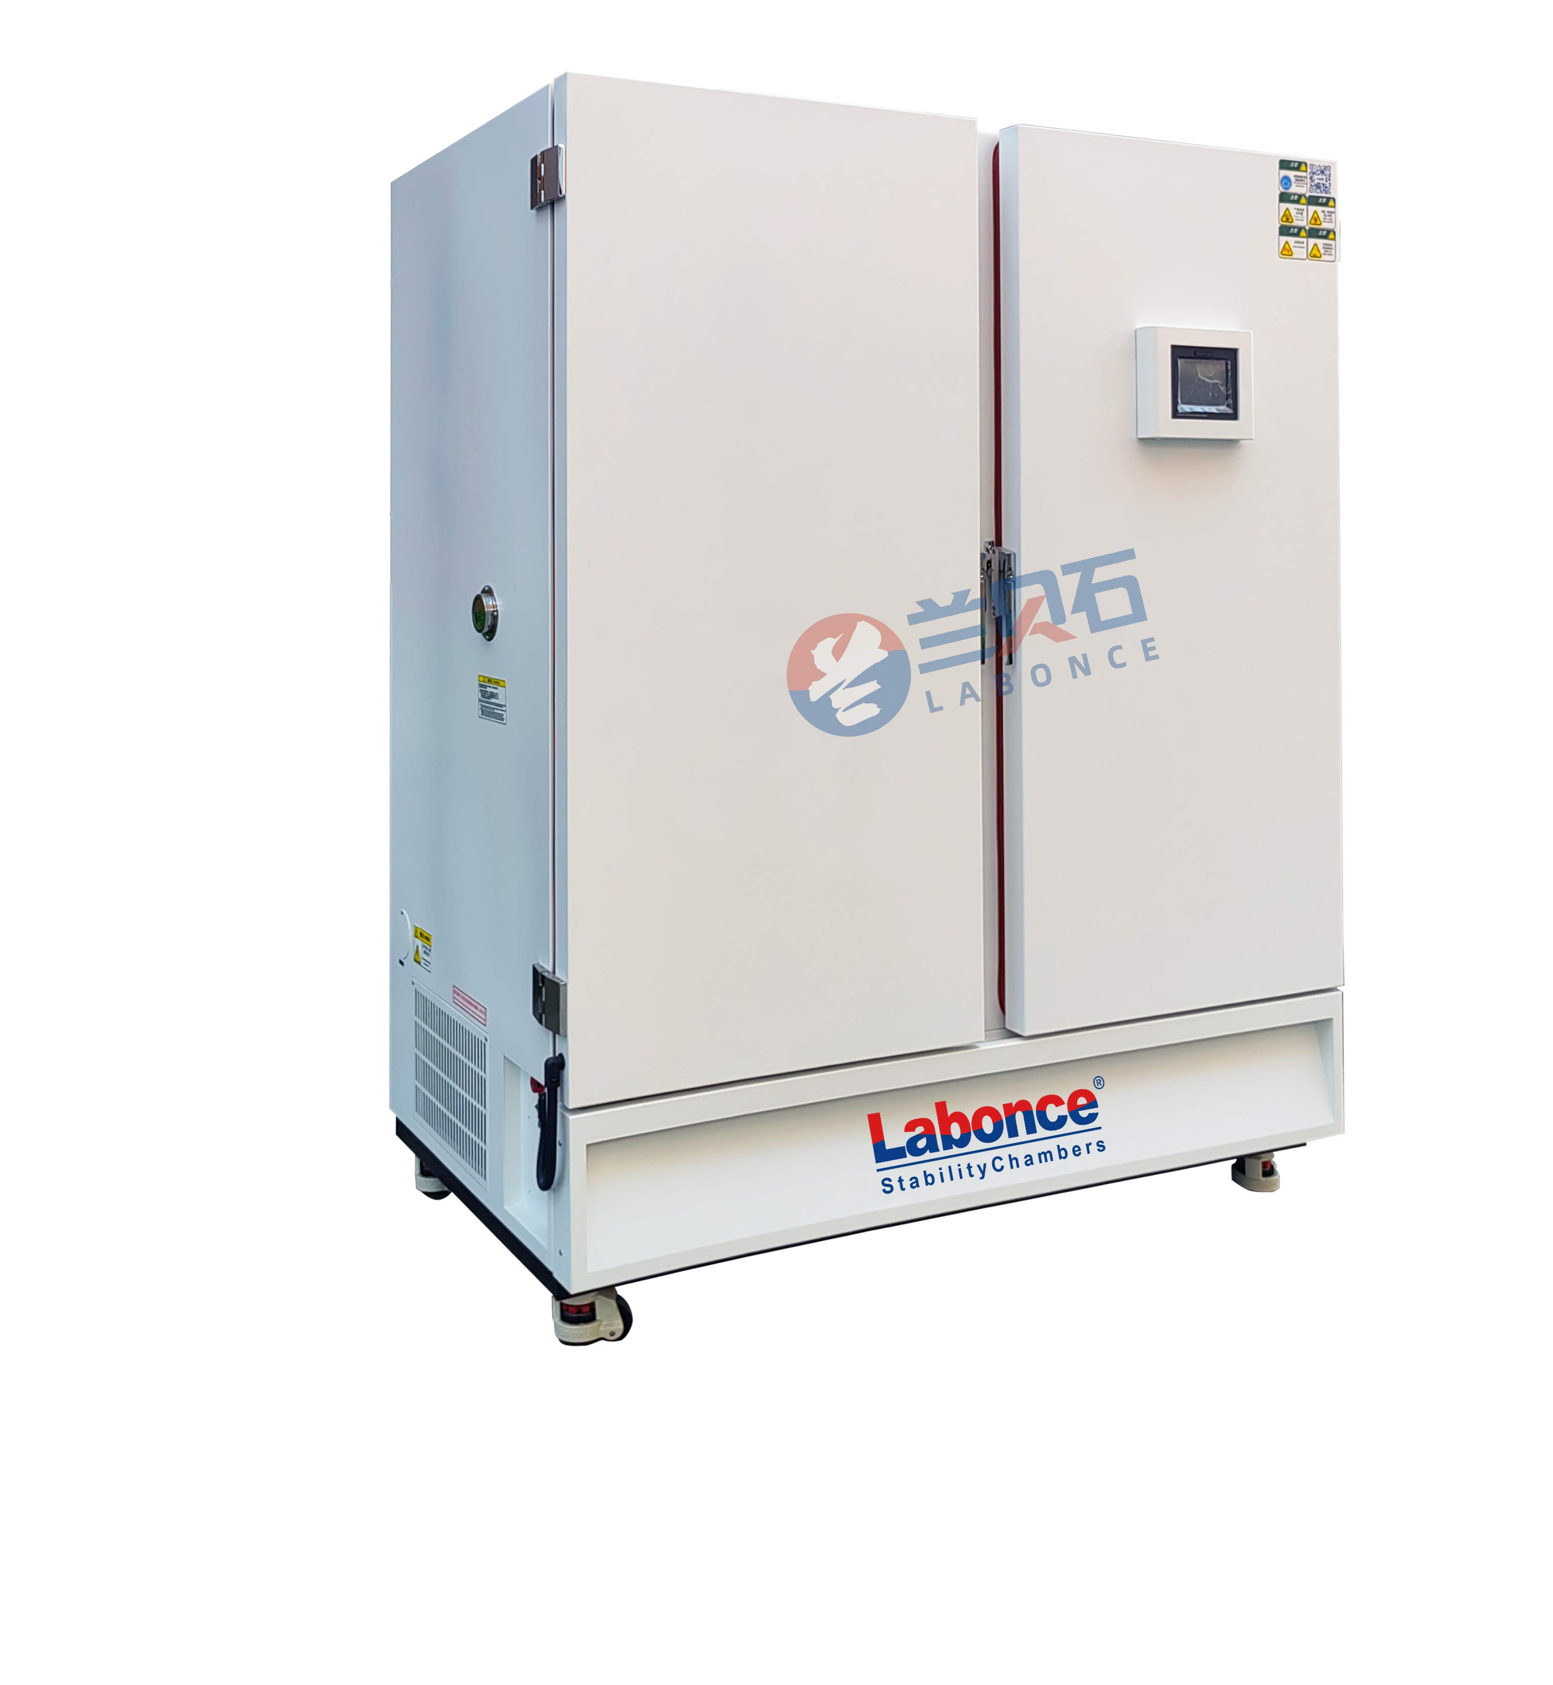
800L

